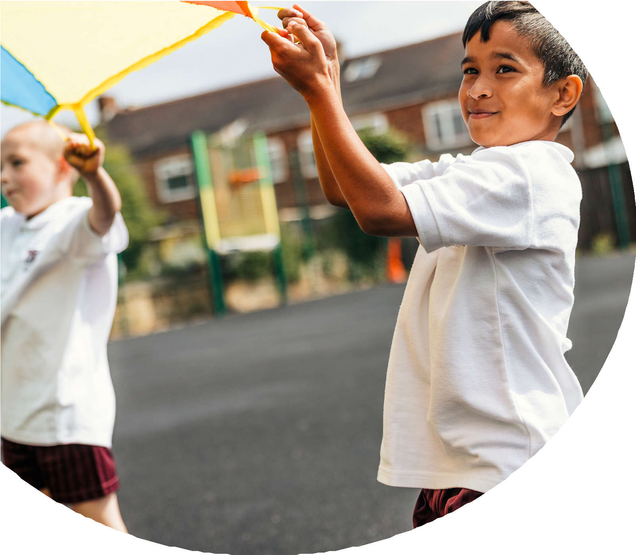
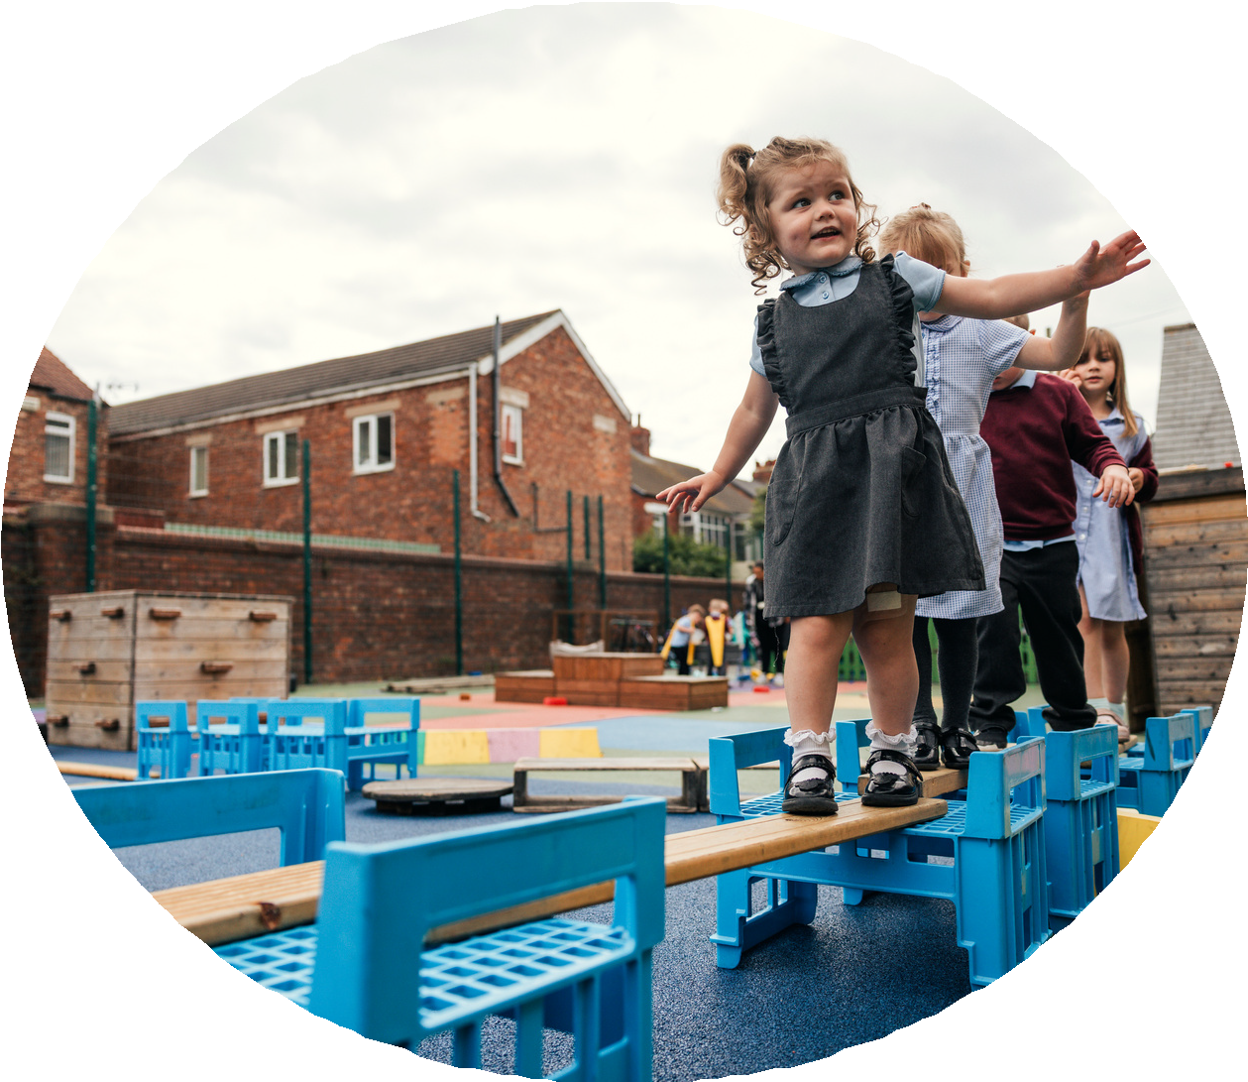

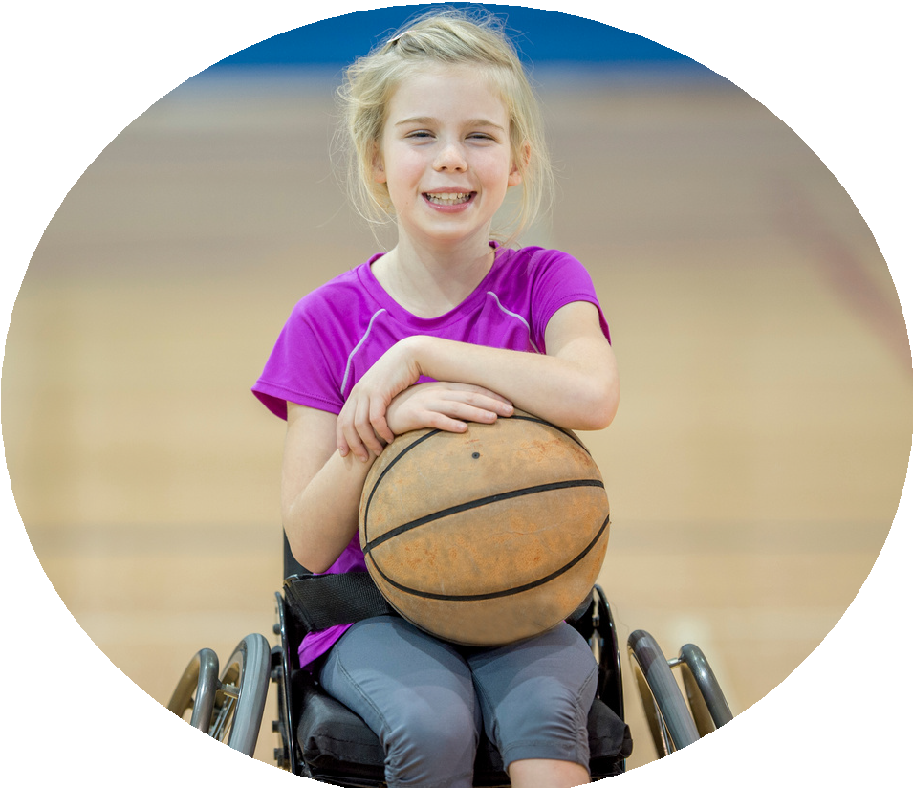



PE and sport premium monitoring and tracking form 2025/2026

Commissioned by

Created by


PE and sport premium monitoring and tracking form
- It is intended that this template should be used as preparation for the completion of the statutory DfE PE and sport premium digital expenditure reporting return. You can upload data (including swimming) from this template onto this platform once it becomes accessible.
- The template is a working document that you can amend and update during the year.
- Before you decide how you are going to use the funding for this academic year you should reflect and evaluate the impact of your use of you PE and sport premium funding in 2024/25.
- You should use your evaluation of last year’s funding to help you decide what to do this academic year, how you will do it, and what impact you expect it to have.
- All spending of the funding must conform with the terms outlined in the conditions of grant
- The summative digital expenditure reporting from June 2026 will continue to include swimming and water safety information. PE and sport premium funding can be used to provide top-up lessons, where necessary, to ensure pupils meet national curriculum swimming requirements
- To ensure funding is used effectively and based on your school’s needs; guidance and examples of best practice across schools can be found here.
- You must use the funding to make additional and sustainable improvements to the PE and sport in your school.
- You must develop and add to the PESSPA activities that your school already offers.

Useful Links:
- Complete the PE and sport premium expenditure reporting return - GOV.UK
- PE and sport premium for primary schools - GOV.UK
- PE and sport premium: conditions of grant 2024 to 2025 - GOV.UK

Review of the last academic year (2024/2025)

Swimming and Water Safety | What went well? Supporting evidence? | What didn't go well? Supporting evidence?
1. Swim competently, confidently and proficiently over a distance of at least 25 metres | N/A to infant school
2. Use a range of strokes effectively (for example, front crawl, backstroke and breaststroke) | N/A to infant school
3. Perform safe self-rescue in different water-based situations | N/A to infant school
- Take some time to reflect on your intent, implementation and impact from last academic year to celebrate your wins but to also think about improvements for the year ahead.
- You do not need to complete every box. Just record the information that is key to your school's priorities and areas of focus.
Remember - Be clear about how you focussed spending on key groups such as SEND, girls and disadvantaged pupils.

Key areas as outlined in PE and sport premium guidance | What went well? Supporting evidence? | What didn't go well? Supporting evidence?
1. Increasing confidence, knowledge and skills of all staff in teaching PE and sporting activities prioritising CPD and training where needed | CPD for all staff delivered by Lancashire PE team. Three separate training sessions for Dance, Games and Outdoor and Adventurous Activities. All Classroom staff – teachers and TA’s took part. Feedback showed that staff gained confidence in teaching and supporting.
2. Increasing engagement of all pupils in regular physical activity and sporting activities | Additional equipment purchased for EYFS outdoor physical activities including large movement equipment, small equipment and trikes and scooters – EYFS children are very active and accessing a range of physical activities throughout the day.  Playground sports equipment has been replenished and the children are active and enjoying practising their skills at playtimes. | Extra curricular after school clubs were not well attended due to many children’s commitment to attending mosque after school.
3. Raising the profile of PE and sport across the school, to support whole school improvement | PE has a high profile around school with children actively engaged in their PE lessons and accessing a range of physical activities and games during playtimes.  The Sports coach is leading some games at lunchtimes and the children are keen to be involved.  Achievements from inter-school competitions have been shared in assembly and children are eager to attend and proud of their achievements.  Sports day was enjoyed by all and feedback from staff, parents and children was positive.
4. Offer a broader and more equal experience of a range of sports and physical activities to all pupils and ensure equal access to sport for boys and girls | A range of appropriate physical activities for EYFS and KS1 are offered. Girls and boys have equal access in PE lessons, playtimes, Sports Day, Deepdale Duck sponsored run and external competitions. The curriculum is mapped out carefully to ensure it is broad and balanced.
5. Increasing participation in competitive sport | We attended all inter schools competitions that were offered for EYFS and Key stage 1 in the local area. We achieved a 1st, a 2nd and two 3rd’s in our new league.

Aims for the next academic year (2025/2026)
- Using your whole school priorities, school development plan and previous PE, school sport and physical activity data, set out your aims for the year ahead.
- Think about specific areas of need such as inactive girls, SEND and disadvantaged pupils
- Remember to also input your swimming data and reflections in the table located at the bottom of this page.
- Consider which of the 5 key areas improvements will be focussing on:
- Increasing confidence, knowledge and skills of all staff in teaching PE and sporting activities prioritising CPD and training where needed.
- Increasing engagement of all pupils in regular physical activity and sporting activities
- Raising the profile of PE and sport across the school, to support whole school improvement
- Offer a broader and more equal experience of a range of sports and physical activities to all pupils and ensure equal access to sport for boys and girls
- Increasing participation in competitive sport
Swimming and Water Safety | Input data | Reflections
1. Swim competently, confidently and proficiently over a distance  of at least 25 metres | N/A to infant school
2. Use a range of strokes effectively  (for example, front crawl, backstroke and breaststroke) | N/A to infant school
3. Perform safe self-rescue in different water-based situations | N/A to infant school

Aim | Why? | Key area | Supporting evidence
Develop balancing and climbing opportunities within the EYFS to support the delivery of the PE lessons on PE passport and during outdoor play. | The balancing and climbing equipment available in the hall for PE lessons means that we need to adapt these parts of the PE lessons for EYFS children as the equipment is small.  There are some opportunities for balancing and low level climbing outdoors in EYFS but this needs developing. | - Increasing engagement of all pupils in regular physical activity and sporting activities  - Raising the profile of PE and sport across the school, to support whole school improvement  - Offer a broader and more equal experience of a range of sports and physical activities to all pupils and ensure equal access to sport for boys and girls. | EYFS PE lesson plans, resource audit and teacher feedback.  EYFS provision audit and feedback from EYFS staff.
Develop the use of the evidence aspect of PE passport. | Staff are confidently using the PE passport to teach and assess lessons. The evidence aspect needs developing following staff training in the Summer term 2025. | - Increasing confidence, knowledge and skills of all staff in teaching PE and sporting activities prioritising CPD and training where needed. | PE passport monitoring.  Feebdack from staff training in Summer 2025.
Improve opportunities for children to access extra curricular sports activities, with equal access for girls and boys, children with SEND and disadvantaged pupils. | The extra curricular activities currently offered are very minimal. We need to increase opportunities for children to be engaged in a range of sporting activities that are age appropriate and show them that there are many sports and physical activities that they can enjoy. | - Increasing engagement of all pupils in regular physical activity and sporting activities  - Raising the profile of PE and sport across the school, to support whole school improvement  Offer a broader and more equal experience of a range of sports and physical activities to all pupils and ensure equal access to sport for boys and girls. | Review of our extra curricular sports provision.
Continue to develop participation in multi-school sports events, including girls and boys, children with SEND and disadvantaged pupils. | Children are keen to participate in sports competitions. The competitions help to strengthen children’s physical skills and their PSHE skills in team building and supporting each other. | - Raising the profile of PE and sport across the school, to support whole school improvement.  - Increasing participation in competitive sport. | Competition feedback from previous years – staff and children.
Aims for the next academic year (2025/2026)

Plan, monitor and evaluate (2025/2026)
- Please aim to use this as a live working document through the year.

- Keep returning to this to evidence adaptations and progress made through the PESSPA opportunities you provide.

- There is no set number of objectives you must have.

- Make as many or as few as you see fit that will support your aims for the year ahead.

- Consider which of the 5 key areas improvements will be focussing on:
- Increasing confidence, knowledge and skills of all staff in teaching PE and sporting activities prioritising CPD and training where needed.
- Increasing engagement of all pupils in regular physical activity and sporting activities
- Raising the profile of PE and sport across the school, to support whole school improvement
- Offer a broader and more equal experience of a range of sports and physical activities to all pupils and ensure equal access to sport for boys and girls
- Increasing participation in competitive sport

Plan, monitor and evaluate (2025/2026)

 | Intent – what is your objective? | Implementation - How will you achieve this? | Impact - What do you hope to see? | Supporting evidence
Plan and monitor | To develop lunchtime play to increase access to a range of physical and sporting activities for both boys and girls. | A sports coach to support lead a range of physical and sporting opportunities at lunchtime.  Purchase additional equipment to replenish the playtime trolley throughout the year. | A range of children engaging in physical activities both girls and boys.  Children enjoying their lunchtime playtimes.  An active playground. | Pupil voice feedback termly.  Lunchtime walk rounds half termly.
 | What impact have you seen? | Are the improvements sustainable? How? | Supporting evidence | Approx. cost
Evaluate |  |  |  | Lunchtime sports coach approx. £5000  Equipment for playtimes approx. £1000

 | Intent – what is your objective? | Implementation - How will you achieve this? | Impact - What do you hope to see? | Supporting evidence
Plan and monitor | To ensure staff have secure subject knowledge to plan, teach, assess and evidence PE lessons effectively and safely. | PE subject lead to attend the local area Network meetings and feedback to staff.  Level 5 course for HLTA to continue teaching PE.  Purchase the ‘Safe Practice in PE 2025’ document and share with staff.  CPD through the Royal Ballet and Opera House for key stage 1 staff.  Continued subscription to the Lancashire PE passport to teach and assess PE lessons. | Teachers are confident teaching PE lessons and have a secure subject knowledge. | PE lesson walk throughs.  Staff feedback.
 | What impact have you seen? | Are the improvements sustainable? How? | Supporting evidence | Approx. cost
Evaluate |  |  |  | Subject leader network meetings x3 (£97 for 2, 3rd one free) - £194  Level 5 course for HLTA - £1250  Safe practice in PE 2025 - £40  Royal Ballet and Opera house CPD for ley stage 1 – £0  PE passport annual subscription approx. £300

 | Intent – what is your objective? | Implementation - How will you achieve this? | Impact - What do you hope to see? | Supporting evidence
Plan and monitor | To provide opportunities for children to access a range of extra-curricular sports and physical activities that are age appropriate, including competitive sports. | Introduce children to junior park run with staff attending.  Attend all local inter-school competitions.  Introduce extra-curricular sports clubs for children to attend.  Sports Day for the whole school.  Celebrate all events and achievements in whole school assemblies. | Children excited and enthusiastic to participate in sporting events.  Parents supporting children at sports events. | Pupil voice after sports events.  Feedback from parents.  Feedback from staff.
 | What impact have you seen? | Are the improvements sustainable? How? | Supporting evidence | Approx. cost
Evaluate |  |  |  | Staffing costs for clubs (3 clubs approx. £60 per week x 38 weeks = £2280)  Inter schools competition entry costs per term approx. £30  Transport costs to competitions approx. £50  Rewards for competitions/ sports day approx. £50

 | Intent – what is your objective? | Implementation - How will you achieve this? | Impact - What do you hope to see? | Supporting evidence
Plan and monitor | To increase opportunities for balancing and climbing within PE lessons and within EYFS provision. | Research balancing and climbing equipment for use within PE lessons and purchase appropriate equipment for EYFS and key stage 1.  Research balancing and climbing equipment to enhance current outdoor provision in both Nursery and Reception and purchase. | Both boys and girls using a wider range of balancing and climbing equipment and developing their strength and co-ordination.  Both boys and girls feeling confident to balance and climb on a range of equipment.  Increased numbers of both boys and girls achieving the Physical Development Early Learning Goal at the end of the EYFS. | EYFS walk throughs in outdoor provision.  Pupil voice.  Teacher feedback.  PE lesson walk throughs.
 | What impact have you seen? | Are the improvements sustainable? How? | Supporting evidence | Approx. cost
Evaluate |  |  |  | Approx. £8000

