

Dear Parents/ Guardians,
As you are already aware, phonics is a very important part of your child’s learning. As extra practise for the phonics screening test next June, it would be extremely beneficial for your child to practise their phonics at home as much as possible. Therefore, we are advising that if you have access to a computer at home, you could use the following website and instructions to ensure your child is practising words which suit where they are up to in their phonics.
1: Website = www.phonicsplay.co.uk

2: Then click on this button:

3: Select phase __________ (This just means where your child is up to in phonics)
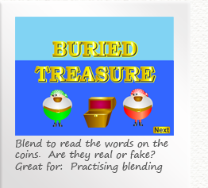
4: Choose one of the free games – ‘Buried Treasure is a useful one as it will show the children a mixture of real/ not real words just like they will have to read in the screening’. The game looks like this:

In order for your child to have the best opportunity in the Phonics Screening, it is recommended that they are familiar with reading words up to phase 5 – if you are unsure about how to pronounce any of the sounds there is a help sheet stapled in your child’s reading record.
If you would like any more help or you have any questions, please ask your child’s teacher .
Yours sincerely,
The Year 1 Team

