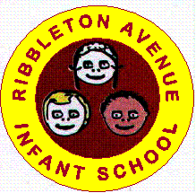
RIBBLETON AVENUE INFANT SCHOOL UNIFORM

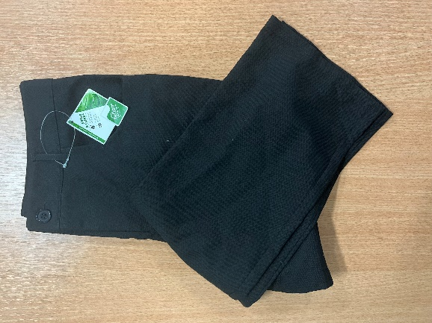
REQUIRED
School Jumper with logo available from the school office.
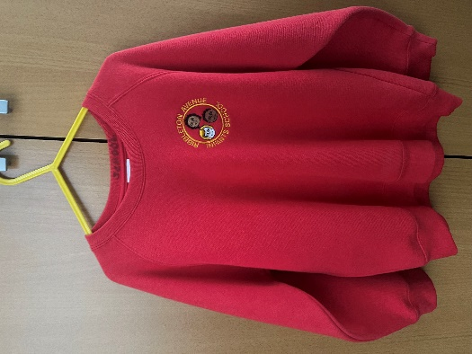

School trousers grey or black. Shorts can be worn in summer.

PREFERRED
REQUIRED
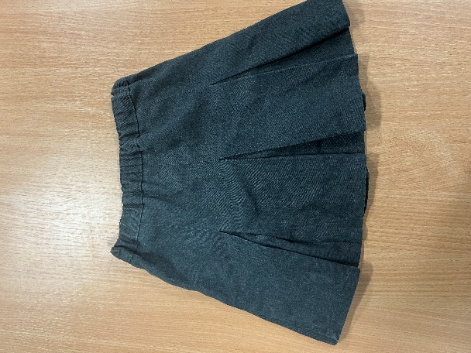
White polo or white shirt available from most supermarkets.
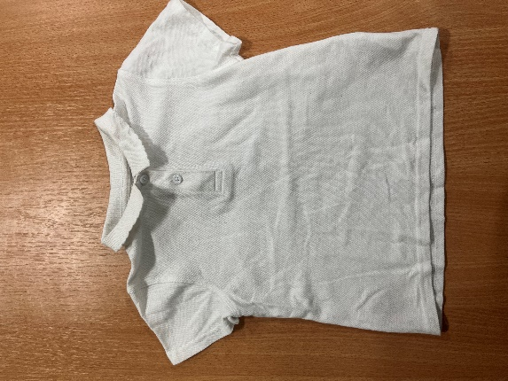
School skirts grey or black

PREFERRED

OPTIONAL
OPTIONAL
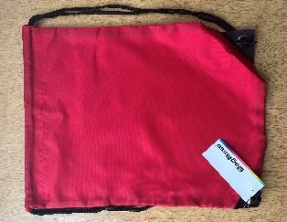
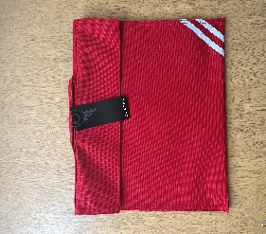
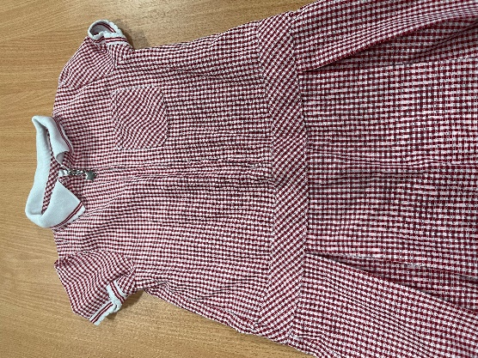
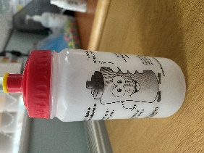
Summer dress red and white check available from most supermarkets

Book bags, Water Bottles and PE bags available from the school office

Black school shoes and black PE pumps. No trainers please.
Please contact school office for current price list.

