Information for Parents & Children attending
Ribbleton Avenue INFANT SCHOOL
NURSERY UNIT
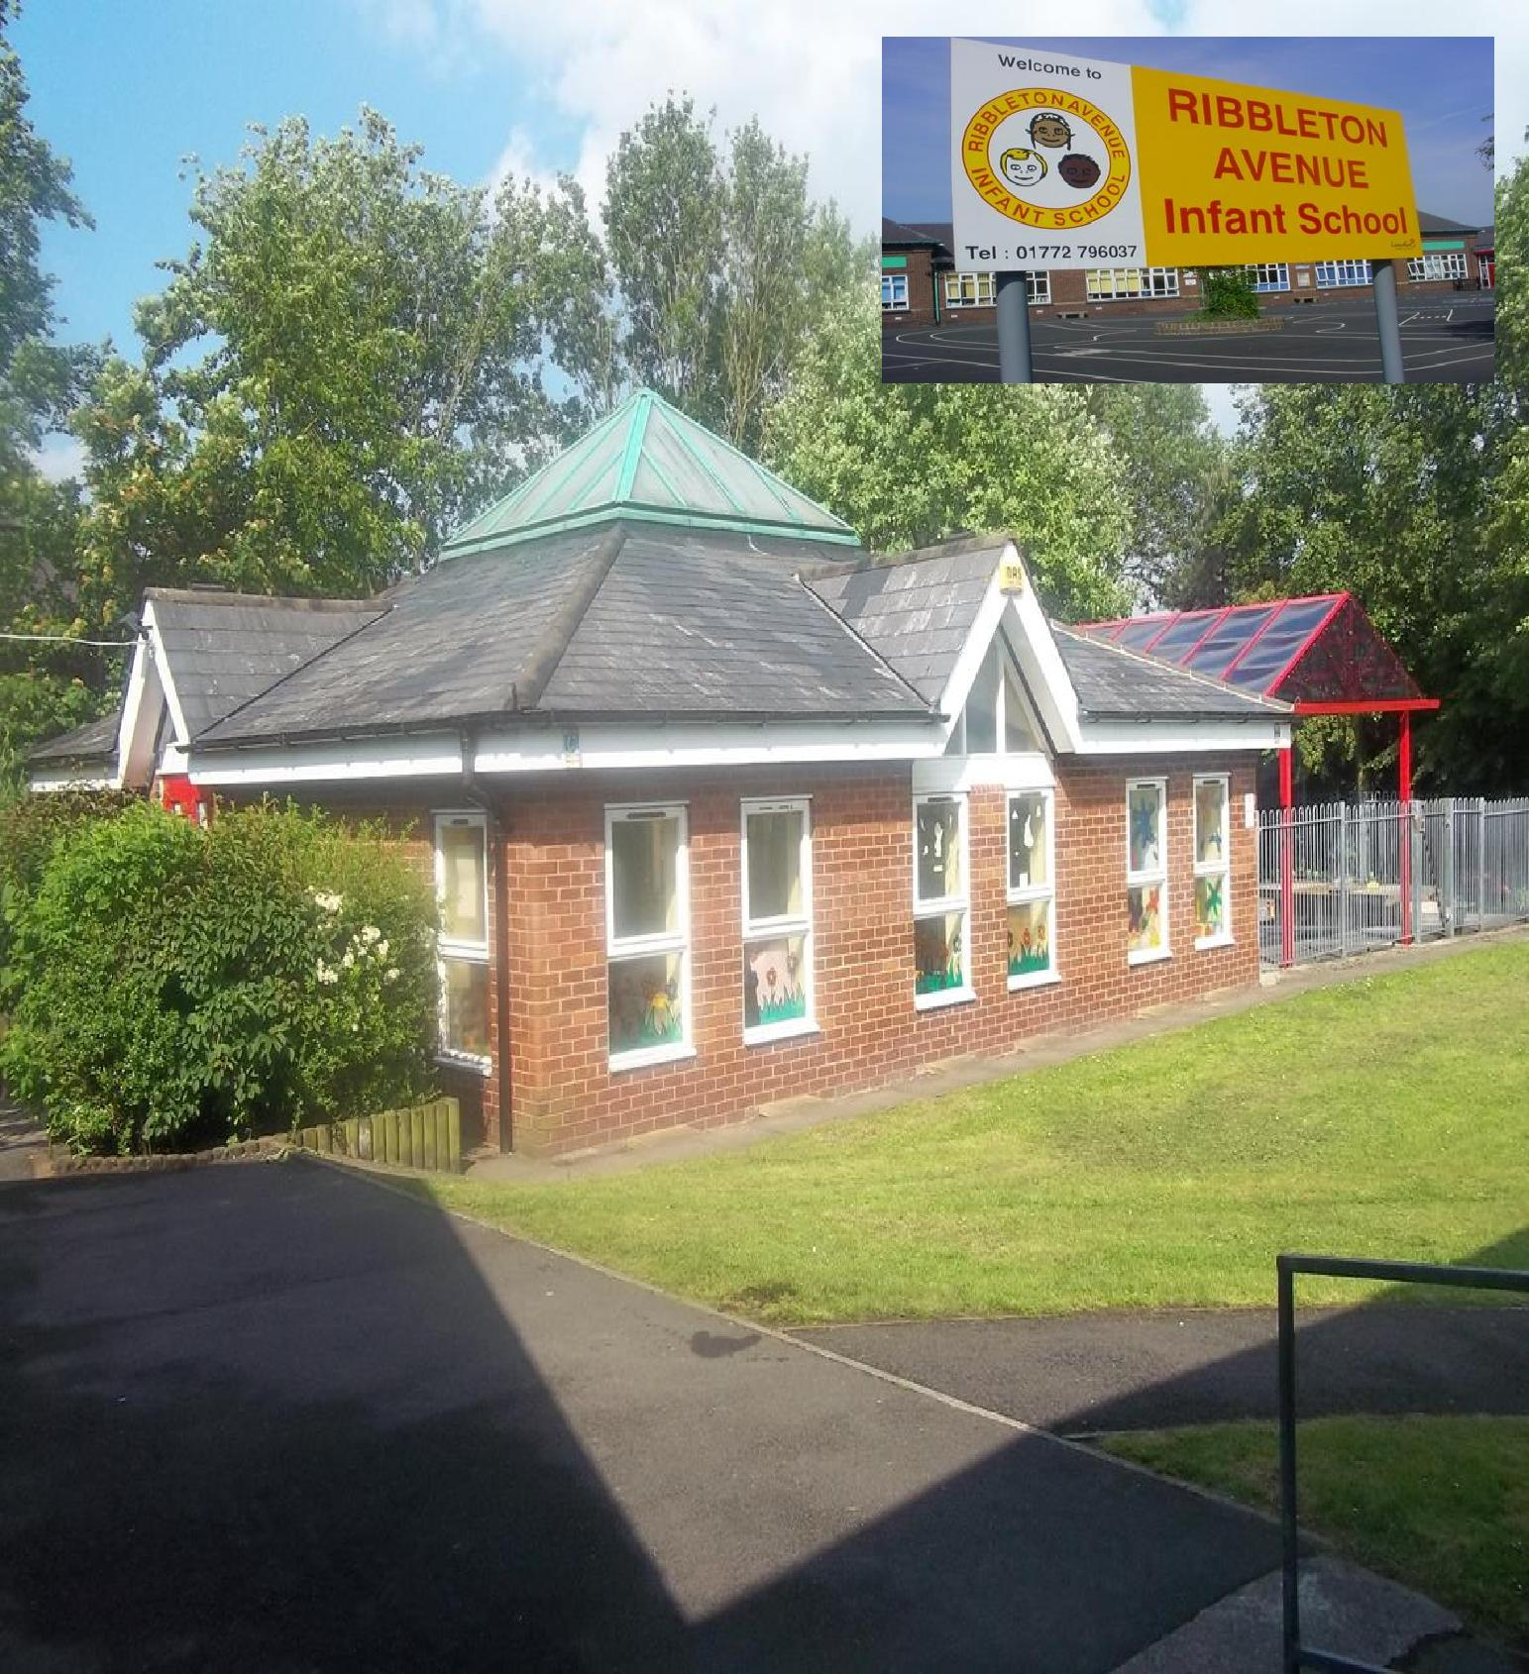
Hello and Welcome to our Nursery!
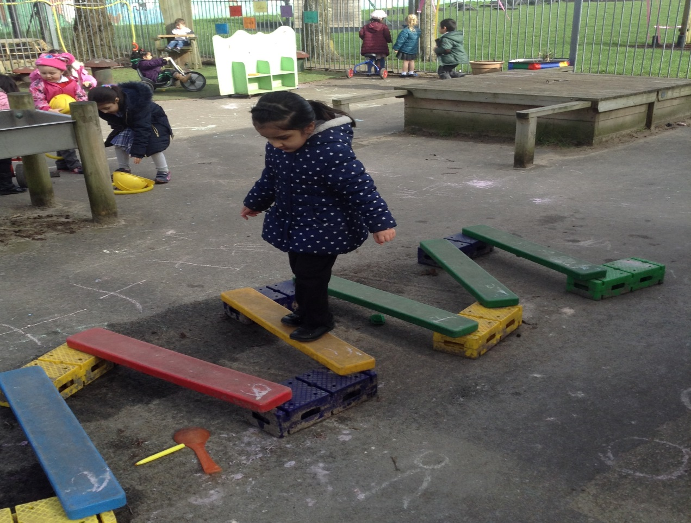
We would like to welcome you to the Nursery Class of Ribbleton Avenue Infant School, where a high standard of achievement, behaviour, and respect for others is encouraged.
Ribbleton Avenue Infants is a popular Foundation and Key Stage One school teaching children from 3 to 7 years old. We had an outstanding OFSTED Inspection report in October 2008 and again in 2013.
Staff and Governors have a strong commitment to the future of our school and are proud of its continued success. We are confident that Ribbleton Avenue Infant and Nursery School can provide an excellent learning journey for your child. All the staff work together to provide high quality education to raise the achievement of your child in a secure and caring environment.
We are very proud of our Nursery and its place at the heart of our community.
Our Nursery is vibrant and dynamic. We provide a stimulating, safe and respectful learning environment, where all members of our staff work in partnership to achieve the best for every child.

We are committed to our School Values:
Respect: Every person has a voice. We listen to and respect each other
Equality: We treat each other fairly,
Pride: We take great care in our presentation, our work and, most importantly, ourselves,
Good Citizenship: We make positive contributions to school, society and beyond.
The Nursery Team

We hope you find the information in this booklet helpful. Please read it and do not hesitate to ask a member of staff if there is anything you are unsure about.

Headteacher: Mrs C. Dring
Nursery Teacher: Mrs R Bateson and Mrs Rhead

Teaching Assistant: Ms. R. Duncan

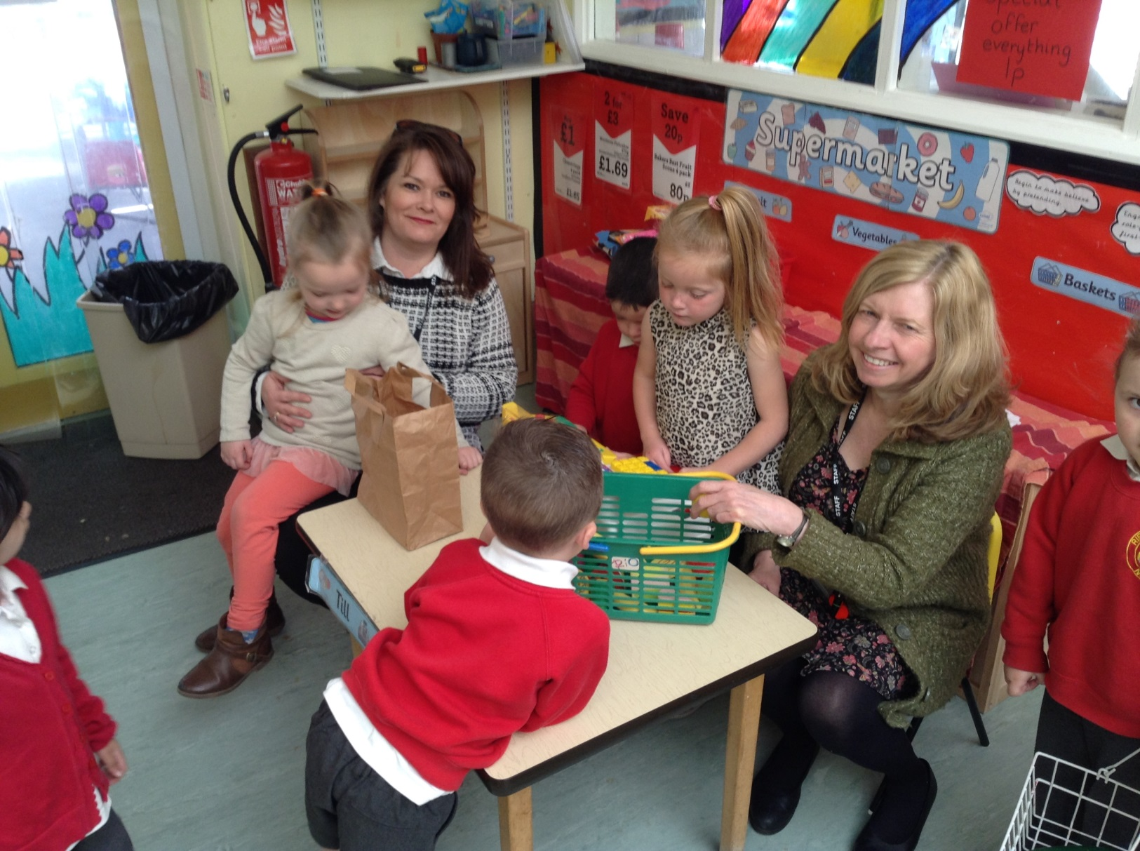
Nursery Sessions
Monday to Friday (Term time only):
5 Mornings: 8.45am to 11.45am or
5 Afternoons: 12.30 pm to 3.30 pm
Your child will attend the Nursery for five mornings or five afternoon sessions per week.
Please note that priority for morning sessions are given to parents whose children already attend Ribbleton Avenue Infant School.
It is important to inform the Nursery staff if your child is to be collected by someone other than the person who usually comes to collect them. Please make sure that your child is brought to the Nursery and collected by a responsible adult. Please note persons under the age of 16 years old will NOT be able to pick children up from the Nursery Unit.
The Curriculum
The staff provide a happy, stimulating learning environment for both you and your child. We pay particular attention to the Personal, social and Emotional wellbeing of the children and each child has their own Key Worker. We provide new experiences through directed activities and structured play. We also respond to spontaneous activities generated by the children themselves.
In addition to the wide variety of activities in the classroom, your child will have stimulating outside visits, walks, shopping trips etc.
It is our aim to encourage your child to build upon their experiences and interests, and to provide opportunities for development and learning.
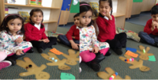
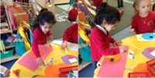
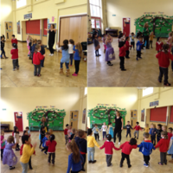

The Sessions
Each session is 3 hours long. Twenty-six children attend each session. During this time the children are encouraged to choose from pre-selected activities and have an opportunity for outside play in accordance with the Early Years Foundation Stage Curriculum.
We do not start formal reading or writing in the Nursery class, but we do provide for the development of pre-writing and number skills. Each day your child will have a short structured session focusing on early phonics or early maths appropriate to their stage of development.
We provide a snack each day consisting of a drink of milk and a piece of fruit.
High self- esteem is the key to success in life and we try to ensure that our children leave us as caring, happy and confident individuals ready to start school.
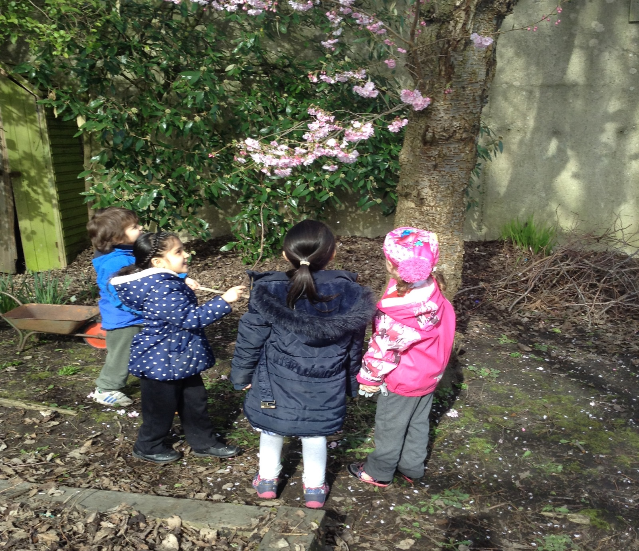

Parents in the Nursery
You are always welcome in the Nursery. We believe that working together with parents enables us to provide an education rich in first-hand experiences. You will find us open, friendly and welcoming. We aim to build a partnership between home and school so that we can work together to achieve the best for your child.
Nursery Fund
Parents can help by supporting our Nursery Fund. Each Term we ask for a voluntary donation of £10 per term or you can pay for the full year this will be £30.00 to provide items used in classroom activities. It also contributes towards the cost of parties, baking and visitors that enrich the curriculum.

Library
From January we provide Library books for your child to bring home and share with you. During the Summer term your child will be able to bring home their first pre reading books in preparation for ‘Big School’.
Attendance and Punctuality
It is important that young children get into a good routine by attending Nursery every day and on time. As with main school, you need to let us know on the first day of absence if your child cannot attend due to Illness. Please telephone the main school on 796037. Children must not take time off for Birthdays, Days out or Shopping Trips.
Please try to make routine medical appointments when your child is not due to attend a Nursery session. If a parent has a medical appointment during their child’s Nursery session then please arrange for someone else to collect your child and inform Nursery Staff of that person collecting.
Remember that a poor attendance record or a period of unauthorised absences of more than 3 weeks may result in your child losing their Nursery place.
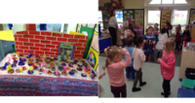

Birthdays
We aim to make the children feel “Special” on their birthday. We have our own pretend ‘cake’ with candles. If you wish to bring your own cake, biscuits or fruit you are most welcome, but please check with our nursery staff first and make sure that it is suitable for all children to eat. However, we ask that you do not bring hard sweets or lollies into the Nursery.
Contact Numbers
It is important that you provide us with a telephone number where you can be contacted should your child become ill whilst at Nursery. Please remember to notify us of any change of address, telephone number or circumstances at home so that our information is kept up-to-date.
Home Life Changes
Changes at home, e.g. separation, divorce, bereavement, new baby, can affect your child at Nursery. Any information that you choose to give the Nursery staff will be treated in confidence.
Governors
The names and addresses of the School Governors are displayed on our website. All parents are eligible to be elected as Governors. If you would like any issues to be raised at Governors Meetings, please contact them via the school office. Parent Governors are elected by parents and serve for a period of four years.
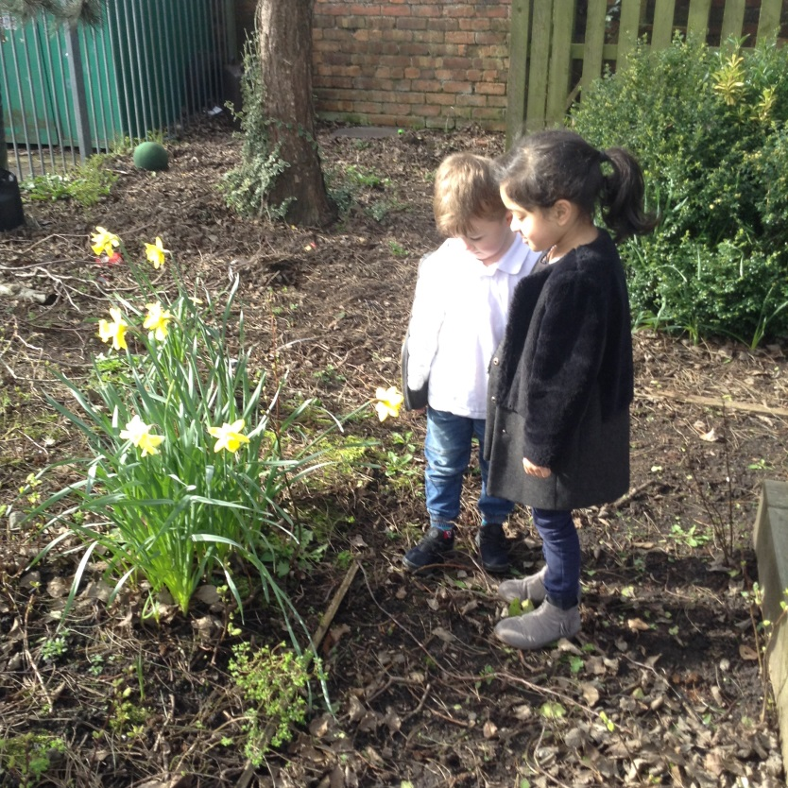
Health and Safety
Jewellery, Studs/Earrings, bracelets and necklaces are particularly hazardous at Nursery and must not be worn. Any item worn for religious purposes is at the parents own risk.
An important part of Nursery Education is for children to play outside on a variety of large toys. It will help us enormously if you can make sure your child is dressed safely for these activities. Long coats are dangerous on bikes as they can get wrapped around the pedals.
Your child might play on a climbing frame so suitable shoes are most important.
Please do not send your child to Nursery in heeled shoes or open toe sandals. Thank you for your help with this.

Nursery Uniform
This is optional but if you wish to send your child in uniform we suggest the following:
- Red sweat-shirt with school logo (available from main office) OR plain red sweatshirt
- White polo shirt
- Grey or Black jogging bottoms
- Dark, low-heeled shoes or trainers
- Warm and waterproof coat
Boots or wellies can be worn to and from nursery but are not suitable for wearing inside nursery, so please bring alternative footwear for them to change into.
Please ensure all items of clothing have your child’s name in.
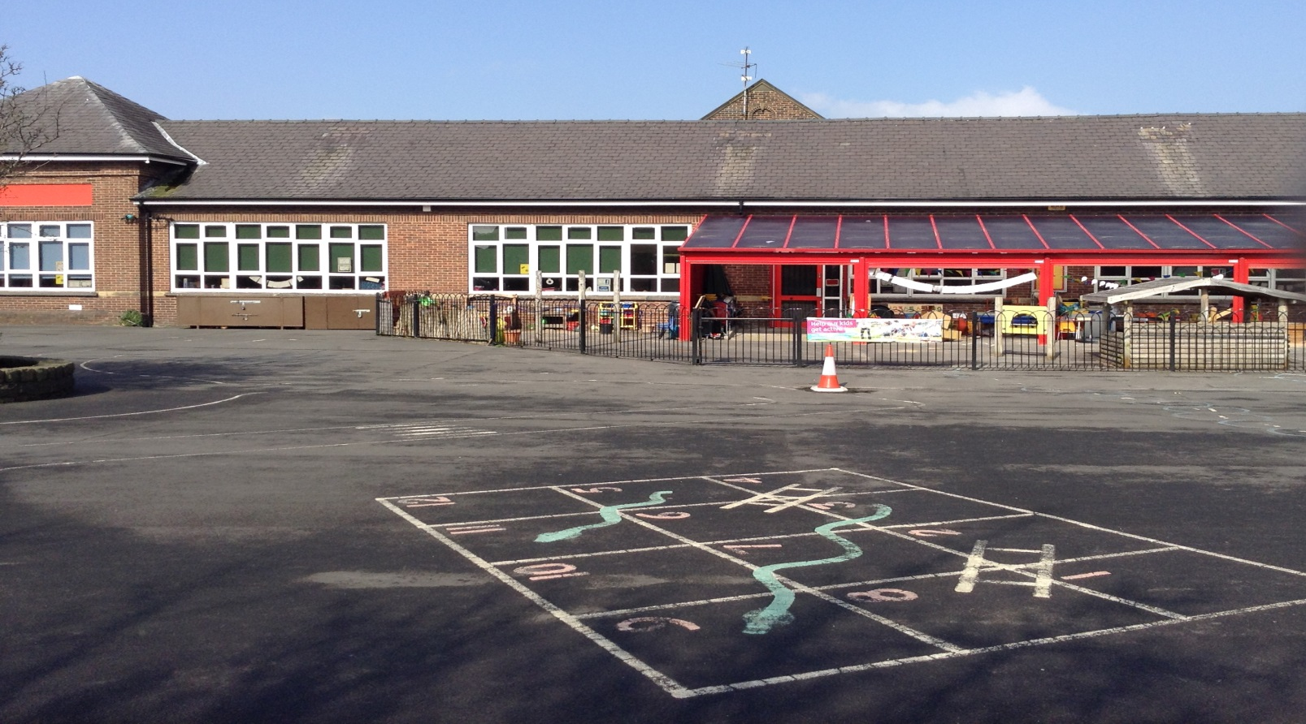
School Admission Criteria
Both Nursery and school are very popular. In Nursery there are 26 morning and 26 afternoon places. Parents can apply directly to school for a place in the Nursery.
In October, all parents of pre-school children are invited to apply for a Reception place via Lancashire Education Authority on-line application form for allocation of places into school for the following September. Parents can fill in the application forms on-line by visiting www.lancashire.gov.uk and follow the link for Admissions.
The Education Authority notifies all parents of their school placement after the Easter holidays.
Infant to Junior School Transfer
Although the majority of Year 2 children move to Ribbleton Avenue Methodist Junior School, there is no automatic transfer from the Infant School to the Junior School.
A separate application form has to be completed. This will be sent to parents of Year 2 children at the appropriate time.
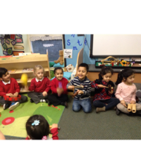
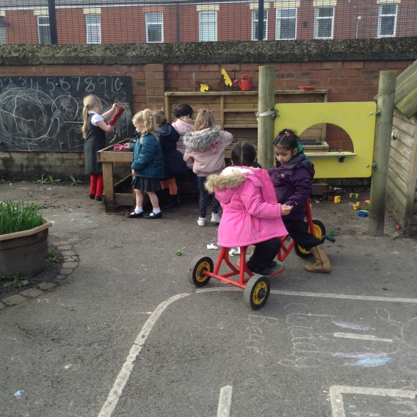
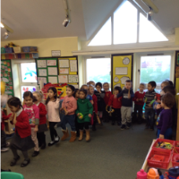

We look forward to meeting you and your child!
From the staff and governors of Ribbleton Avenue Infant School and Nursery.

