Art and Design Cycle A (1) Artist focussed work
Nursery
Focussed Artist | Art skill focus | Theme | Artwork
Henri Matisse | Painting | Colour me a Rainbow | 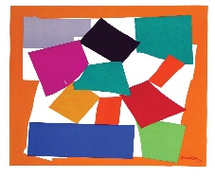
Piet Mondrian | Drawing | Nursery Rhymes | 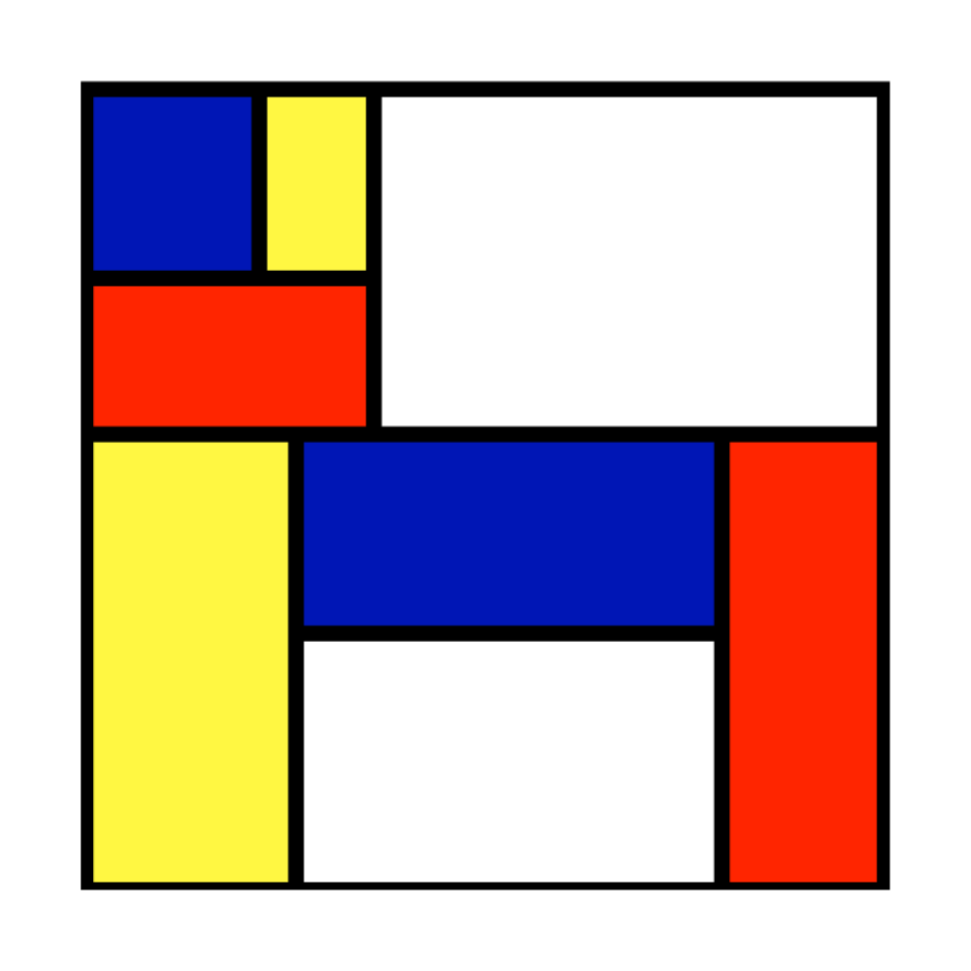
Louise Bourgeois | Sculpture | Down at the bottom of the Garden | 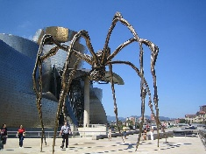

Reception
Focussed Artist | Art skill focus | Theme | Artwork
Pablo Picasso | Drawing | Only One You | 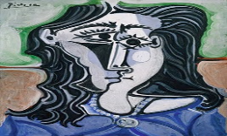
Giuseppe Arcimboldo | Painting | Where does it come from? | 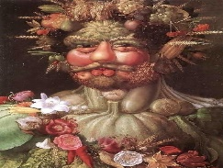
Barbara Reid | Sculpture | Jungle | 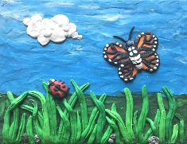

Doves Reception
Focussed Artist | Art skill focus | Theme | Artwork
Clarice Cliff | Drawing | People who helped us. | 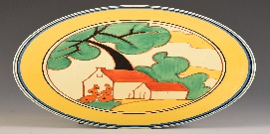
Van Gogh | Painting | Home Sweet Home | 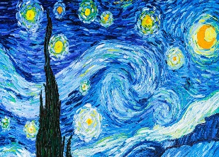
Romeo Britto | Sculpture | Pirates | 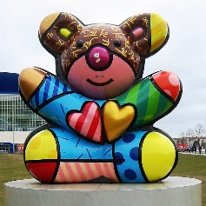

Year 1
Focussed Artist | Art skill focus | Theme | Artwork
Clarice Cliff | Drawing | People who helped us.
Van Gogh | Painting | Home Sweet Home
Romeo Britto | Sculpture | Pirates

Year 2
Focussed Artist | Art skill focus | Theme | Artwork
Roy Lichtenstein | Painting | Great Explorers | 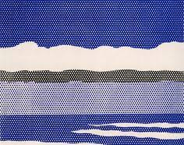
Georgia O’Keefe | Drawing | Paddington | 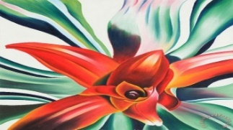
Augusta Savage | Sculpture | Rainforest | 

