Charanga Music unit overview Cycle A and Reception

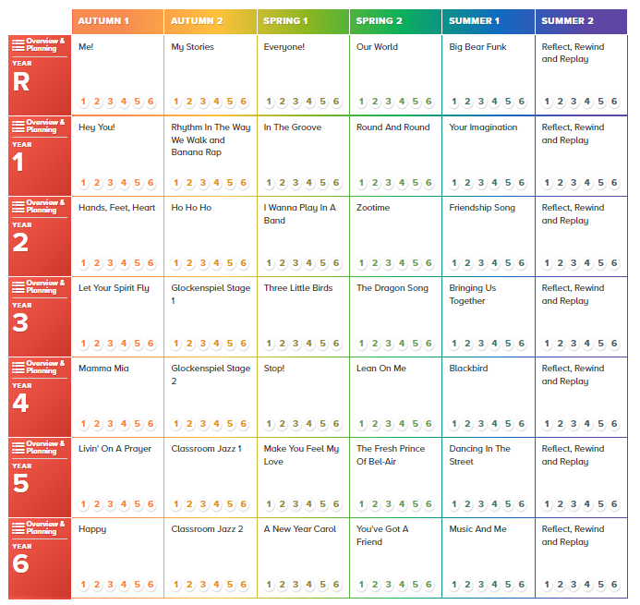

Charanga Music unit overview Cycle B



