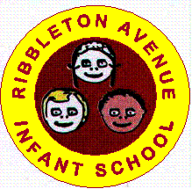
What is Operation Encompass?
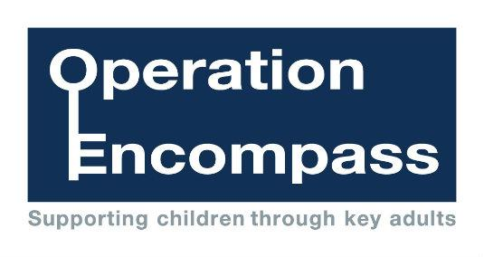


The purpose of Operation Encompass is to safeguard and support children and young people who have been involved in or witness to a vulnerable child incident . Domestic abuse impacts on children in a number of ways. Children are at increased risk of physical injury during an incident, either by accident or because they attempt to intervene. Even when not directly injured, children are greatly distressed by witnessing the physical and emotional suffering of a parent.
Child criminal exploitation (CCE) is child abuse where children and young people are manipulated and coerced into committing crimes. CCE is a form of modern slavery that sees children forced to work under the control of organised criminal gangs.
The victim may have been criminally exploited even if the activity appears consensual. CCE does not always involve physical contact; it can also occur through the use of technology.
Encompass has been created to address such situations that create a safeguarding risk to young people. It is the implementation of key partnership working between the police and schools/ colleges. The aim of sharing information with local schools/ colleges is to allow ‘Key Adults’ the opportunity of engaging with the child and to provide access to support that allows them to remain in a safe but secure familiar environment.
Following the report of a domestic abuse, child missing from home incident or vulnerability to exploitation incident, by 9.00am on the next school / college day the school / post 16 provider’s Key Adult will be informed of the child or young person’s involvement. This knowledge, given to educational establishments through Operation Encompass, allows the provision of immediate early intervention through silent or overt support dependent upon the needs and wishes of the child/ young person.
The purpose and procedures in Operation Encompass have been shared with all parents and governors, is detailed as part of the educational establishment’s Safeguarding Policy and published on our website.
At Ribbleton Avenue Infant School our Key Adult is:
Mrs C Dring (Headteacher)

